TUTORIAL 2
- In the figure below, With the B and C inputs inverted, determine the output and show the timing diagram. 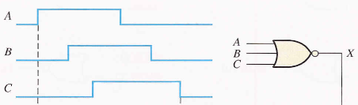

- For the input waveforms below, determine the output and timing diagram
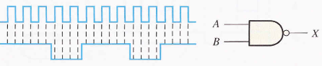
- Repeat problem 1 above for an XOR gate.
- Repeat problem 2 above for an XNOR gate.
- Determine which of the logic circuits below are equivalent.

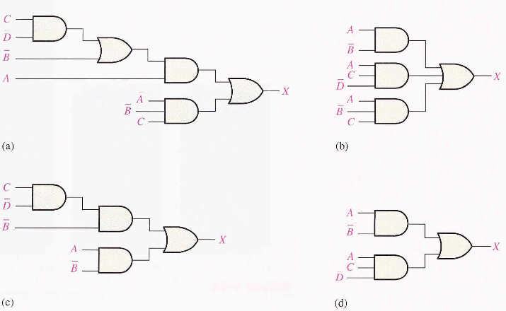

- Convert each expression to standard SOP form

